Questions

ISM - EC2 - MidSem

Module 1: Basic Probability & Statisitcs

CS 1 - Measures of Central Tendency & Measures of Variability, Data – Symmetric & Asymmetric, outlier detection, 5 point summary, Introduction to probability

Question Papers

2022-2023 (28th Jan 2023) MidSem (Makeup) (DSE)

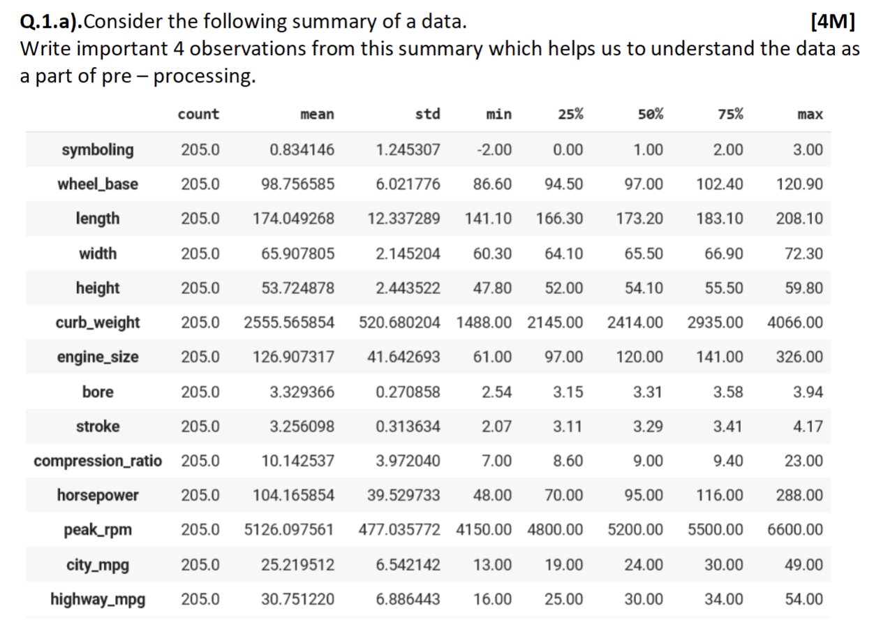

2022-2023 (8th Jan 2023) MidSem (Regular) (DSE)
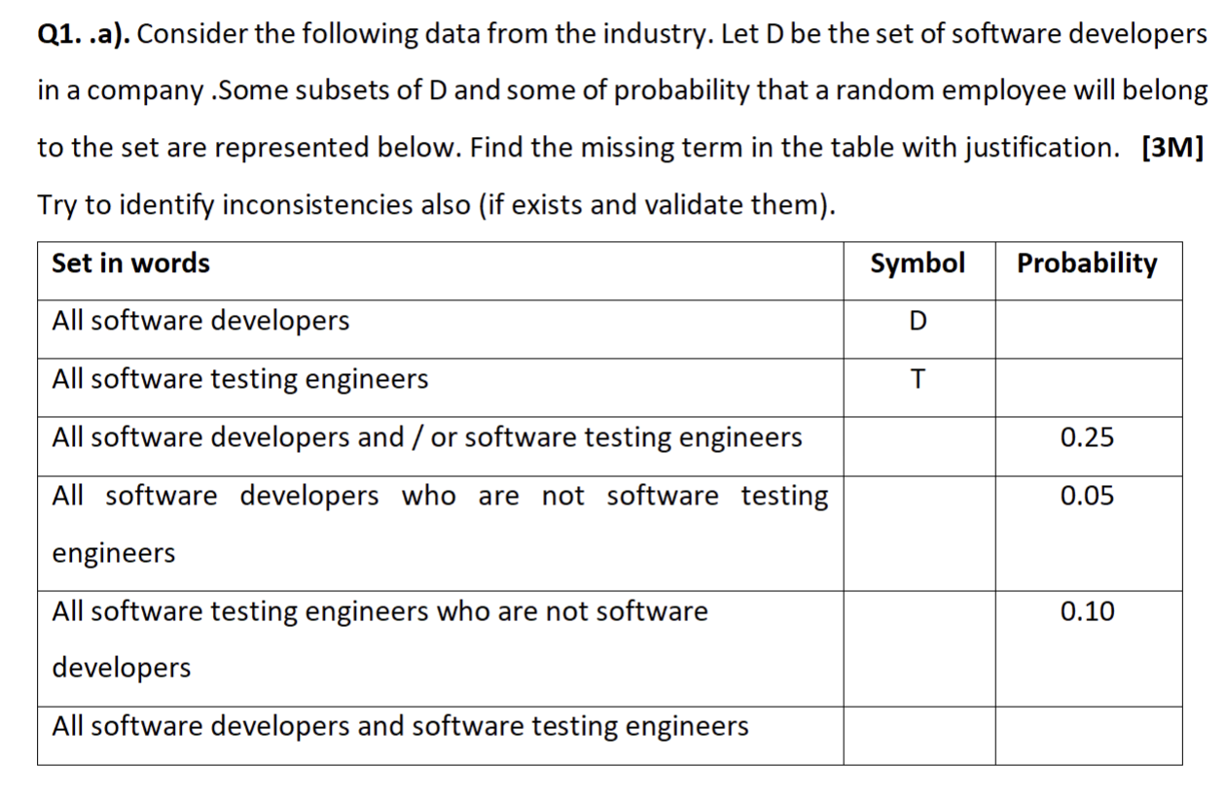
2022-2023 (16th July 2023) MidSem (Regular) (AI&ML)
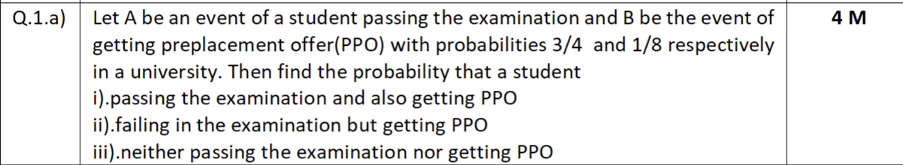
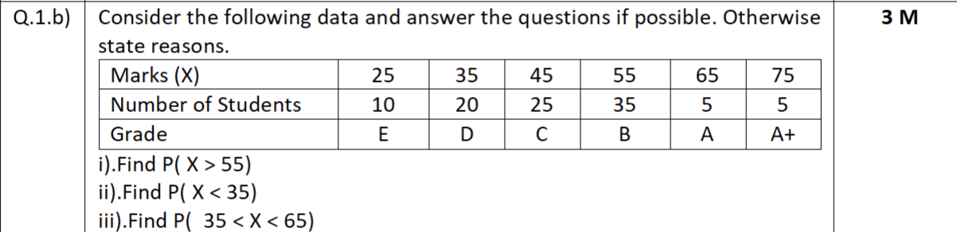

2023-2024 (03rd Feb 2024) MidSem (Makeup) (AI&ML)

2025-2026 (18th Jan 2025) MidSem (Regular) (AI&ML)
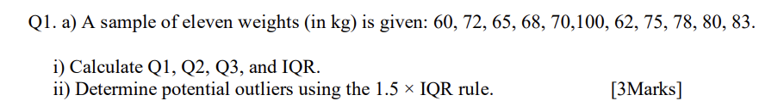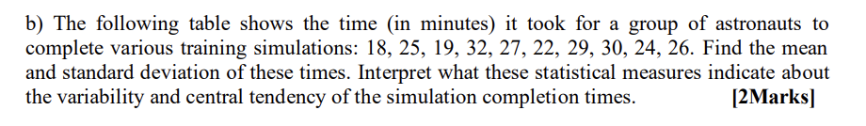
2024-2025 (28th Jun 2025) MidSem (Makeup) (AI&ML)
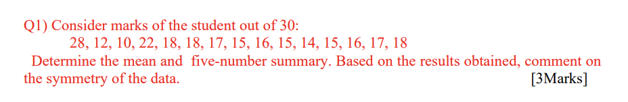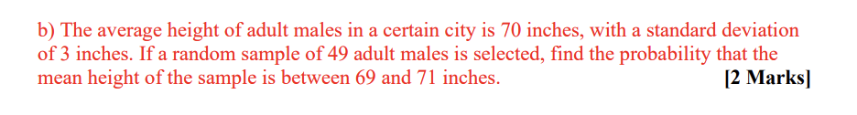

Webinars

CS 2 - Axioms of Probability, Mutually exclusive and independent events, Problem solving to understand basic probability concepts

Question Papers

2022-2023 (28th Jan 2023) MidSem (Makeup) (DSE)
Q1.
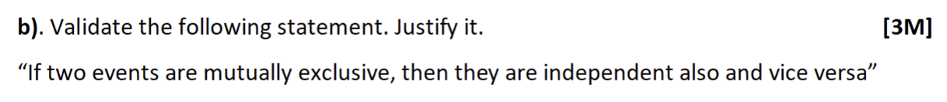

2023-2024 (21st Jan 2024) MidSem (Regular) (AI&ML)
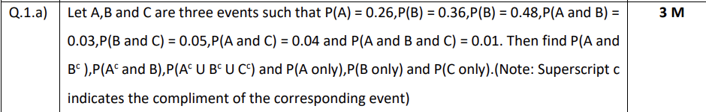

2023-2024 (03rd Feb 2024) MidSem (Makeup) (AI&ML)
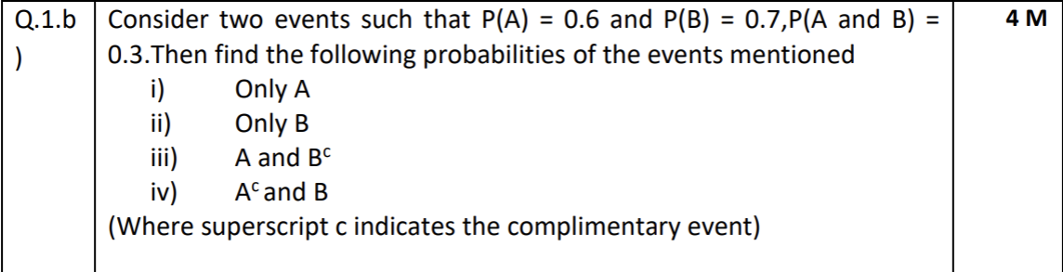

Webinars

Module 2: Conditional Probability & Bayes theorem

CS 3 - Introduction to conditional probability, independent events, Total probability

Question Papers

2022-2023 (28th Jan 2023) MidSem (Makeup) (DSE)
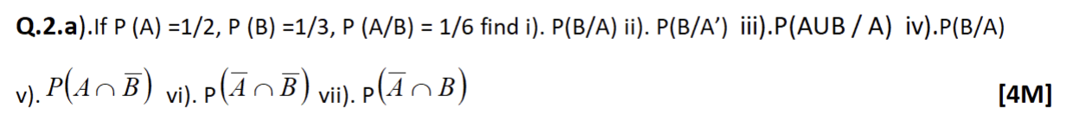
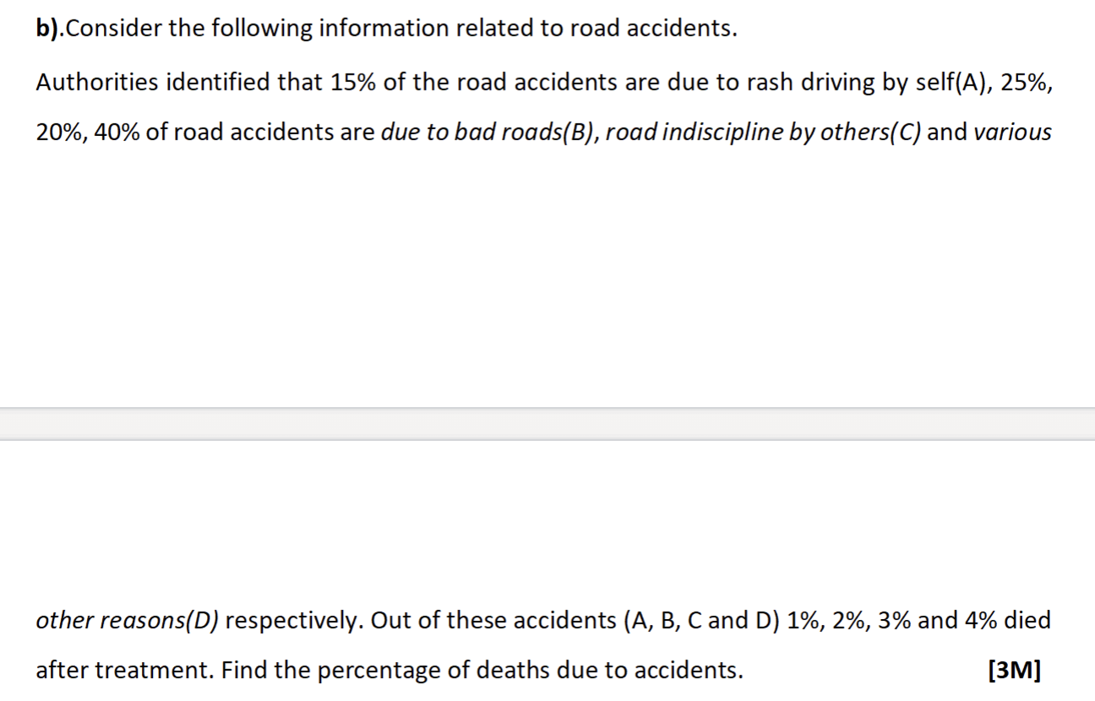

2022-2023 (8th Jan 2023) MidSem (Regular) (DSE)
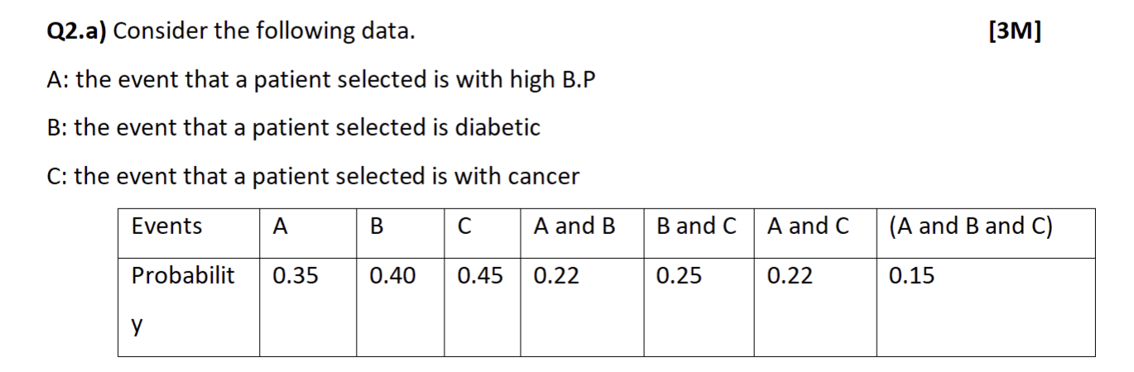
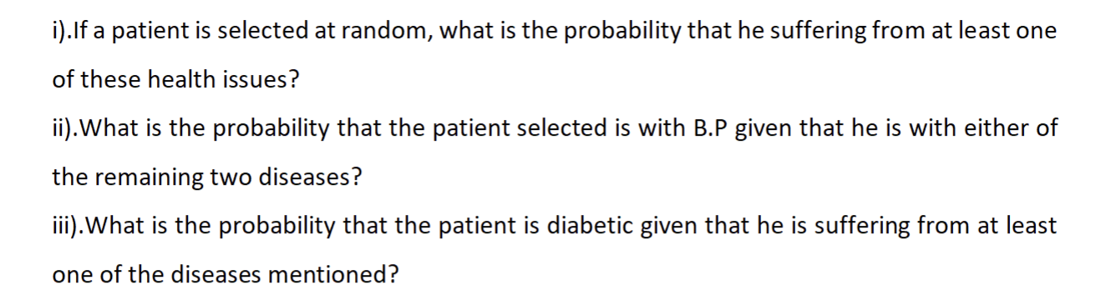

2022-2023 (16th July 2023) MidSem (Regular) (AI&ML)

2022-2023 (02nd April 2023) EndSem (Regular) (DSE)
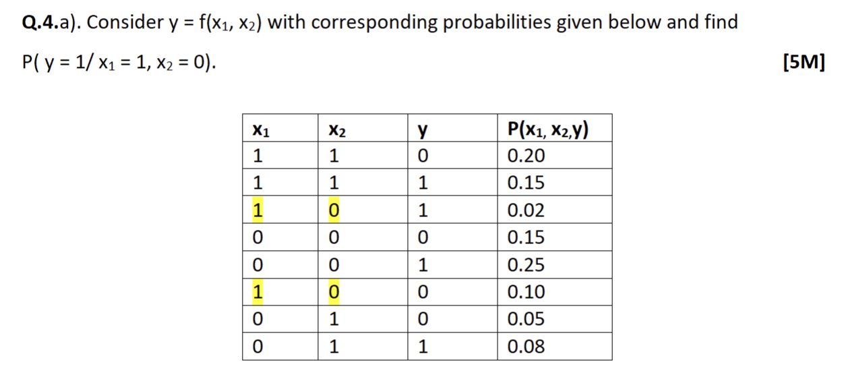

2022-2023 (15th April 2023) EndSem (Makeup) (DSE)
Q4.
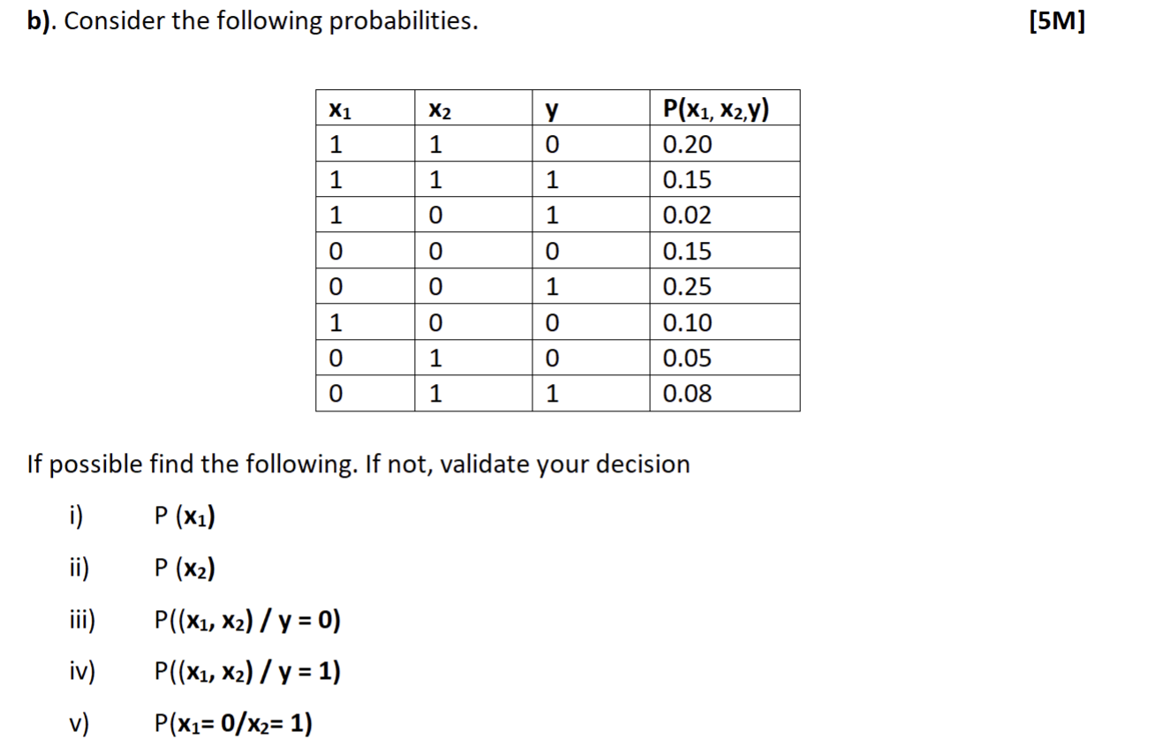

2023-2024 (21st Jan 2024) MidSem (Regular) (AI&ML)

2023-2024 (03rd Feb 2024) MidSem (Makeup) (AI&ML)
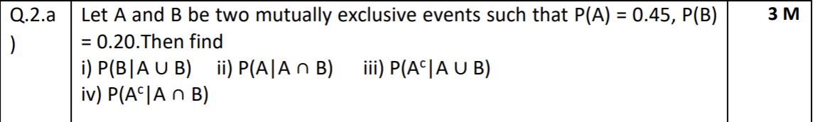

Webinars

CS 4 - Bayes theorem(with proof), Introduction to Naive Bayes concept.

Question Papers

2022-2023 (8th Jan 2023) MidSem (Regular) (DSE)
Q2.
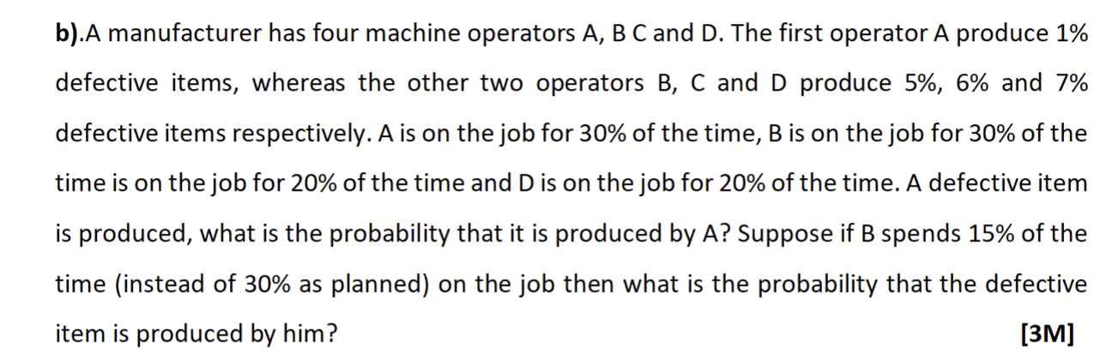

2022-2023 (16th July 2023) MidSem (Regular) (AI&ML)
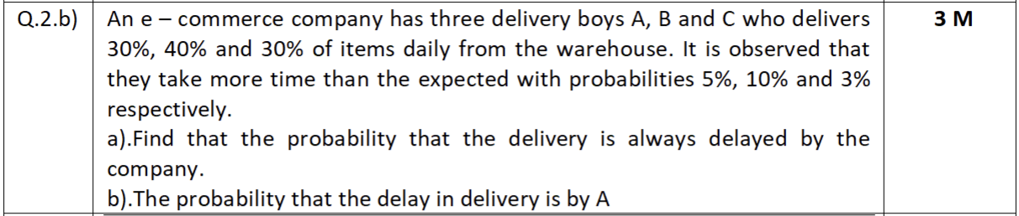

2023-2024 (21st Jan 2024) MidSem (Regular) (AI&ML)
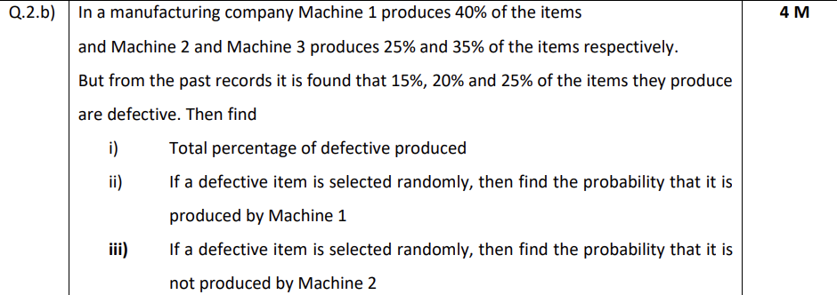

2023-2024 (03rd Feb 2024) MidSem (Makeup) (AI&ML)
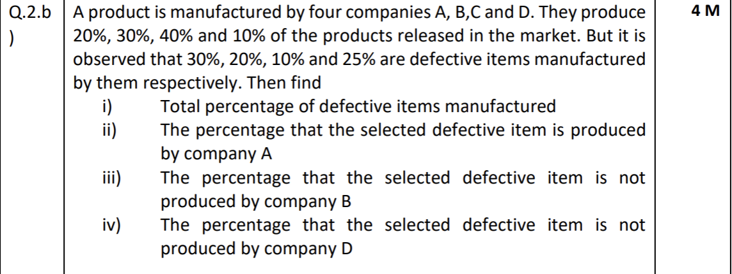
2025-2026 (18th Jan 2025) MidSem (Regular) (AI&ML)
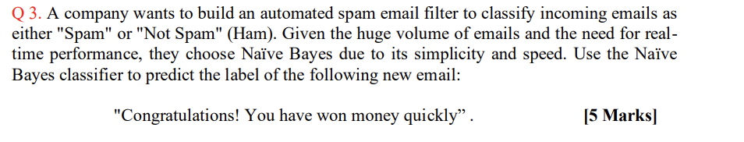
2025-2026 (18th Jan 2025) MidSem (Regular) (AI&ML)

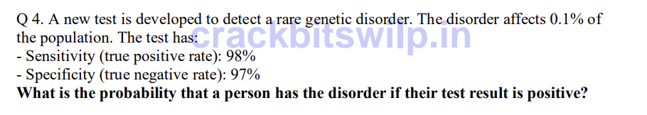

2024-2025 (28th Jun 2025) MidSem (Makeup) (AI&ML)

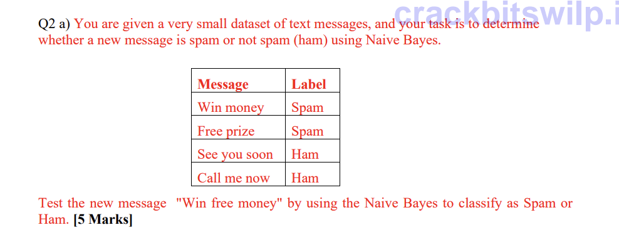
2024-2025 (28th Jun 2025) MidSem (Makeup) (AI&ML)

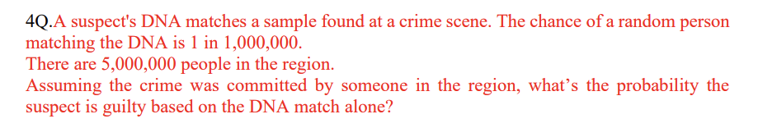

Webinars

Module 3: Probability Distributions

CS 5 - Random variables - Discrete & continuous, Expectation of a random variable, mean and variance of a random variable - Single random, random variable & Joint distributions

Question Papers

2022-2023 (28th Jan 2023) MidSem (Makeup) (DSE)
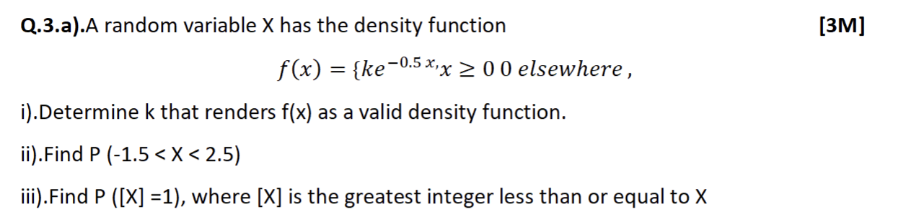
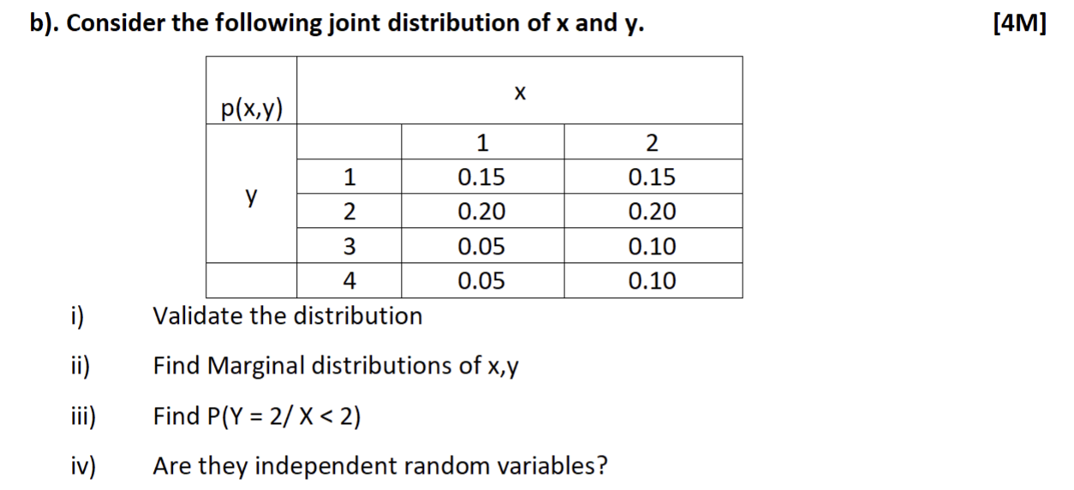

2022-2023 (8th Jan 2023) MidSem (Regular) (DSE)
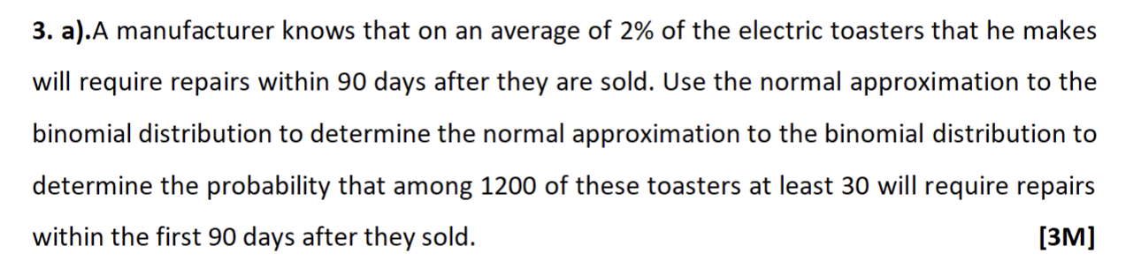
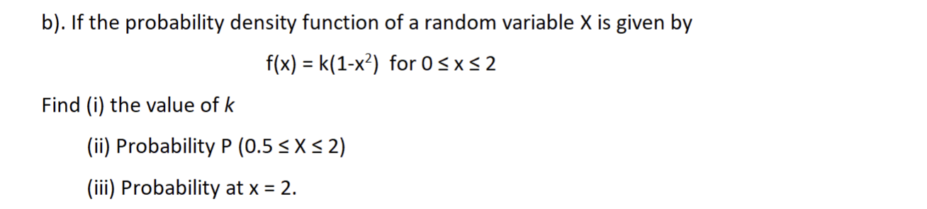
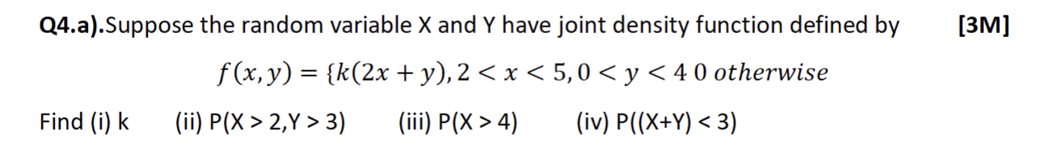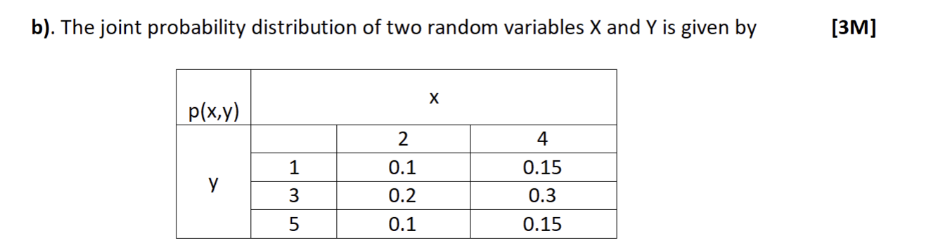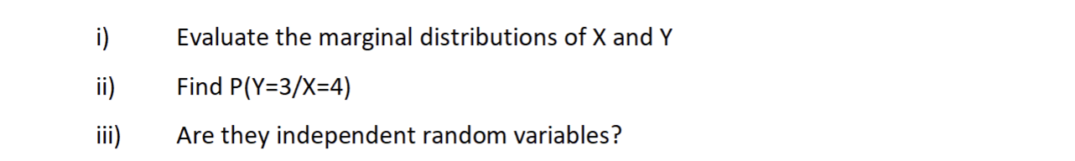

2022-2023 (16th July 2023) MidSem (Regular) (AI&ML)
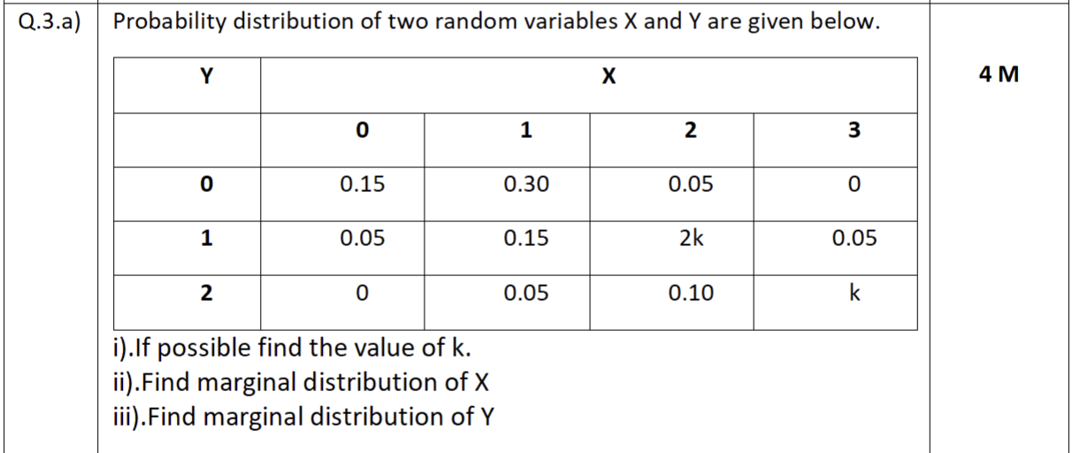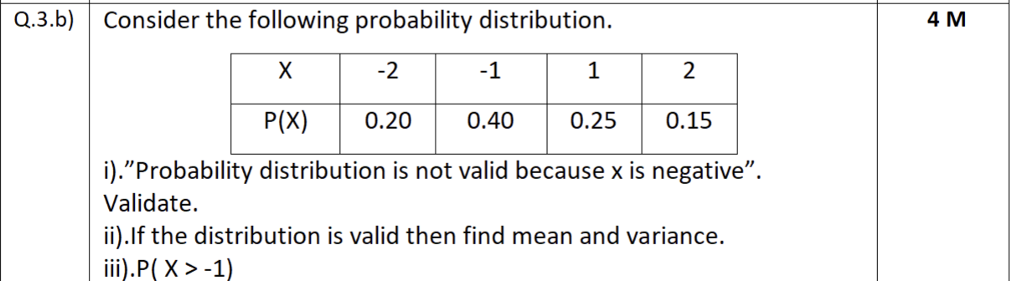
2023-2024 (21st Jan 2024) MidSem (Regular) (AI&ML)
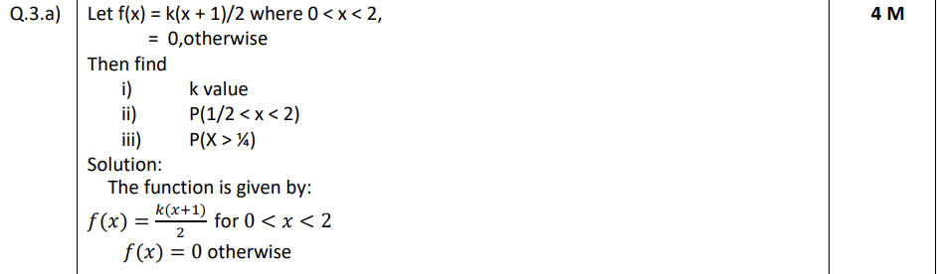

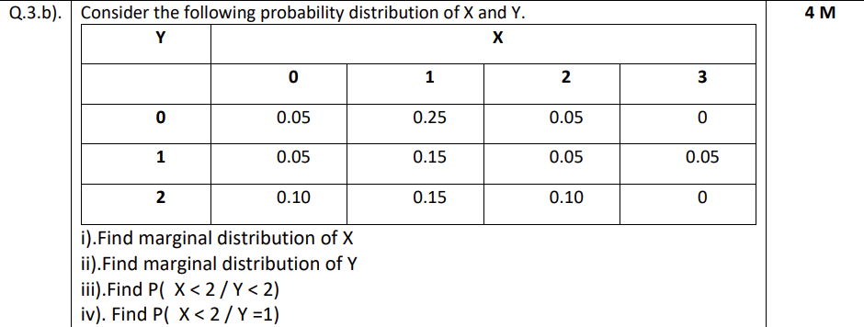

2023-2024 (03rd Feb 2024) MidSem (Makeup) (AI&ML)
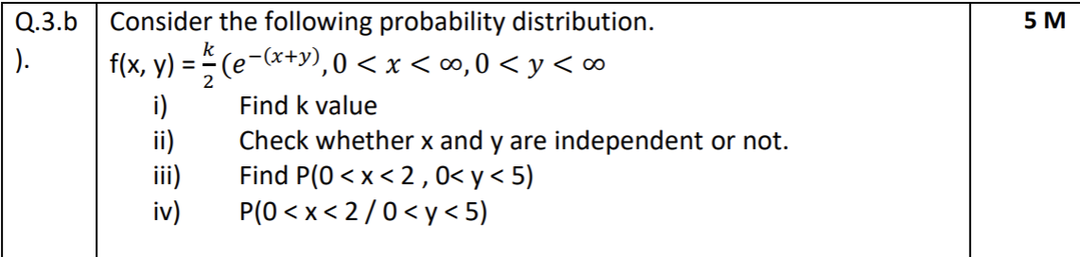

2023-2024 (Apr 2024) EndSem (Regular) (AI&ML)
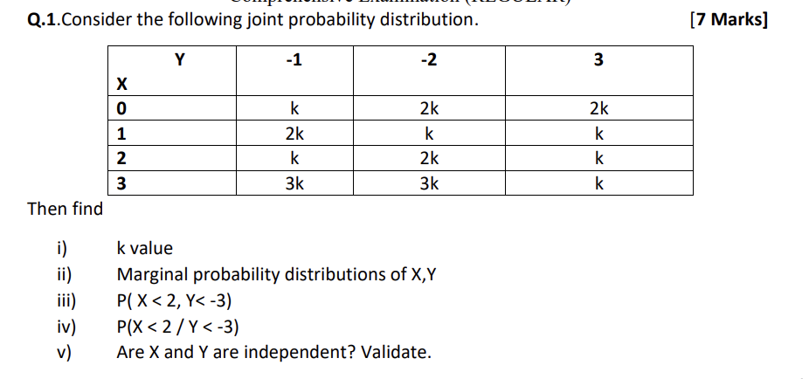
2023-2024 (April 2024) EndSem (Makeup) (AI&ML)
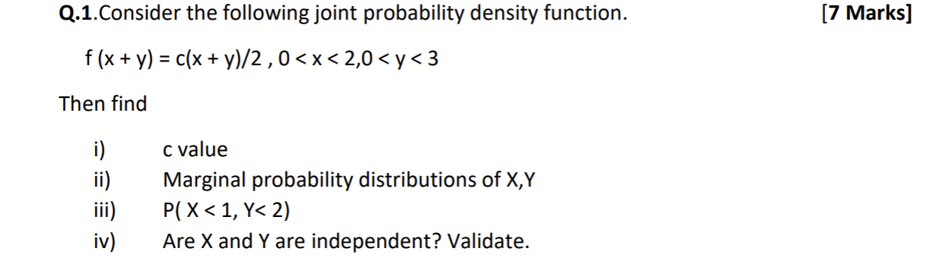
2025-2026 (18th Jan 2025) MidSem (Regular) (AI&ML)

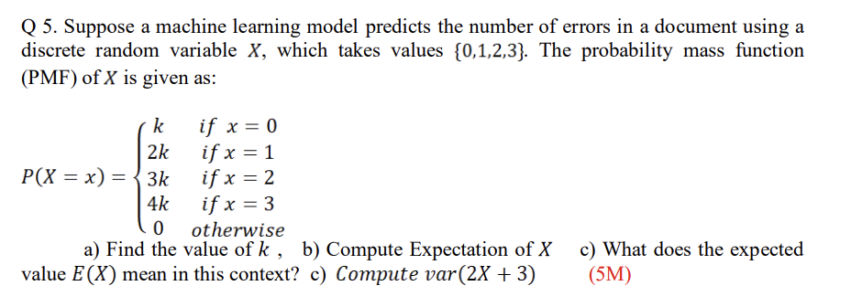
2025-2026 (18th Jan 2025) MidSem (Regular) (AI&ML)

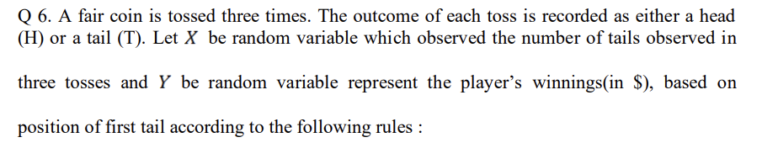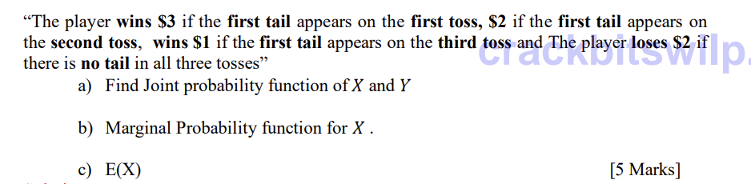

2024-2025 (28th Jun 2025) MidSem (Makeup) (AI&ML)

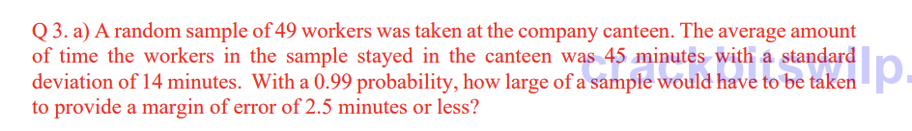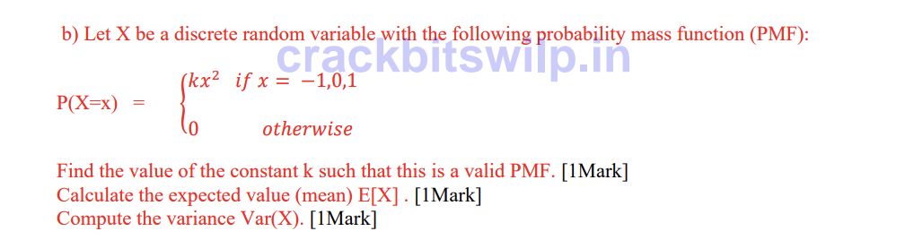

2024-2025 (28th Jun 2025) MidSem (Makeup) (AI&ML)

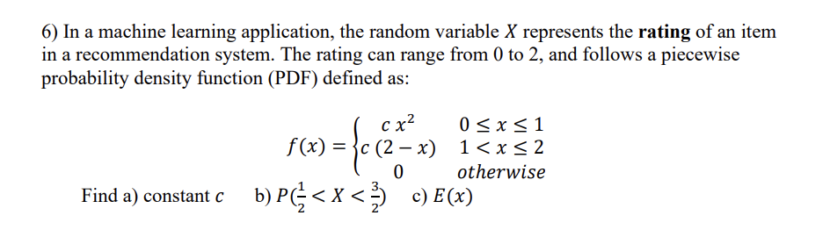

Webinars

CS 6 - Bernoulli, Binomial, Poisson and Normal distributions. Introduction to t - distribution , F - Distribution and Chi Square distributions

Question Papers

2022-2023 (28th Jan 2023) MidSem (Makeup) (DSE)
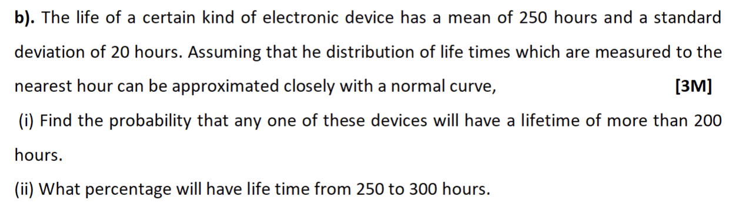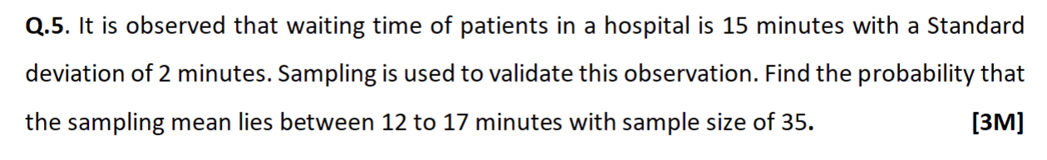

2022-2023 (8th Jan 2023) MidSem (Regular) (DSE)
Q1.

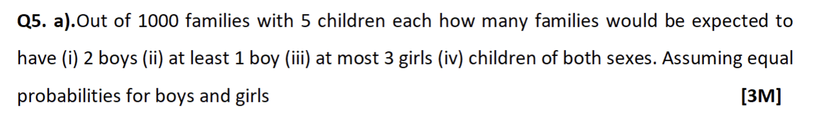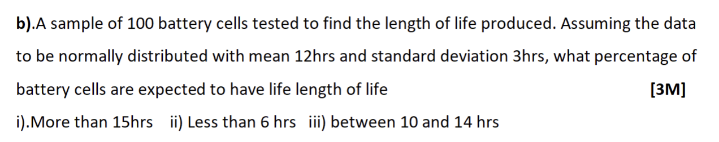

2022-2023 (16th July 2023) MidSem (Regular) (AI&ML)
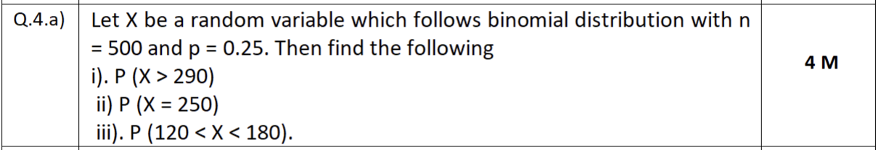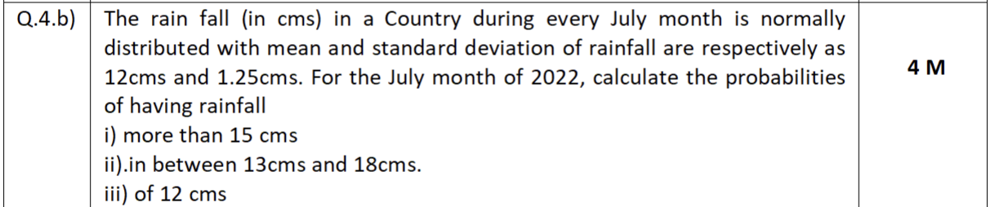

2022-2023 (02nd April 2023) EndSem (Regular) (DSE)
Q3.
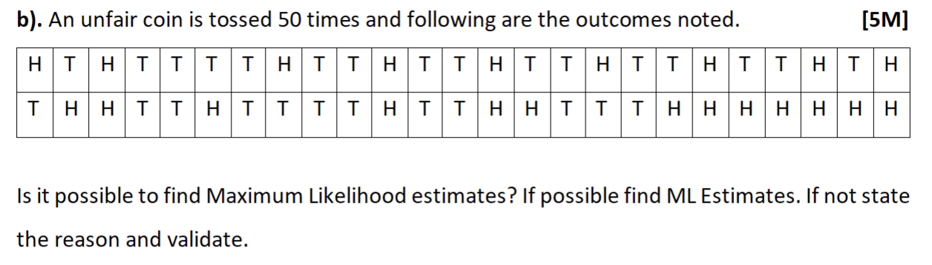

2022-2023 (15th April 2023) EndSem (Makeup) (DSE)

2023-2024 (21st Jan 2024) MidSem (Regular) (AI&ML)
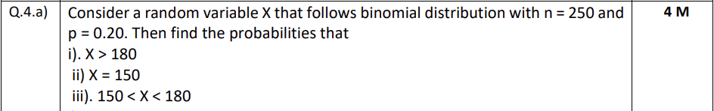
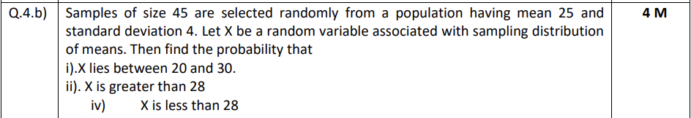

2023-2024 (03rd Feb 2024) MidSem (Makeup) (AI&ML)
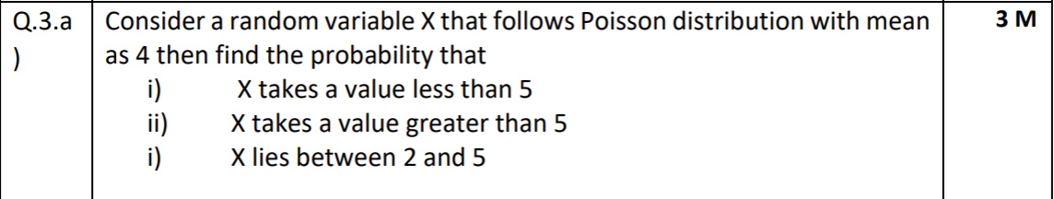
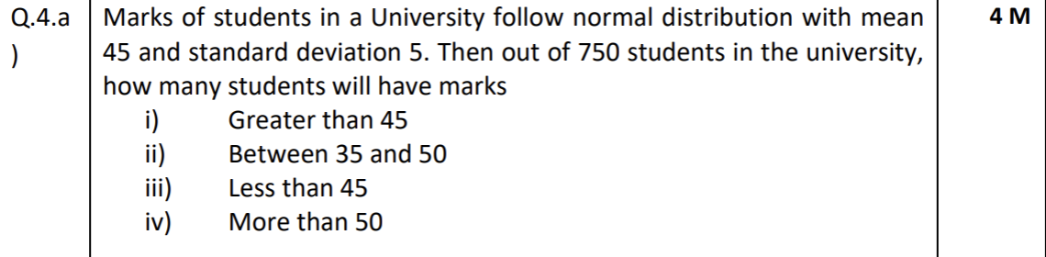
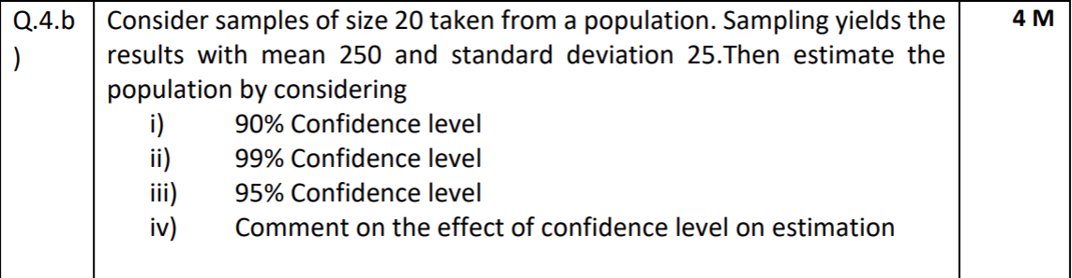

2025-2026 EndSem (Regular) (AI&ML)
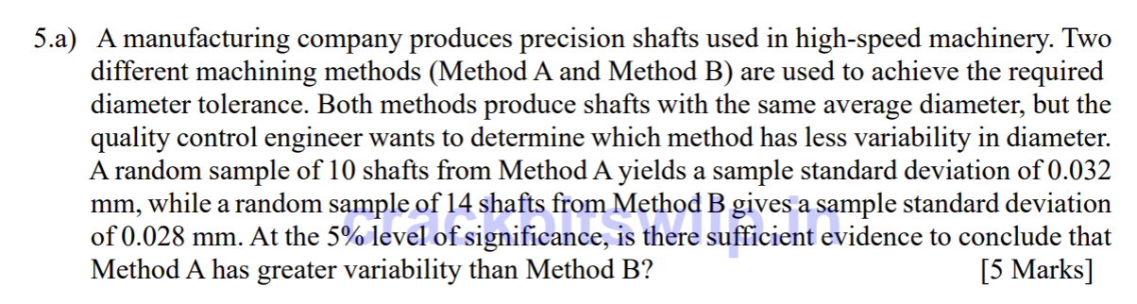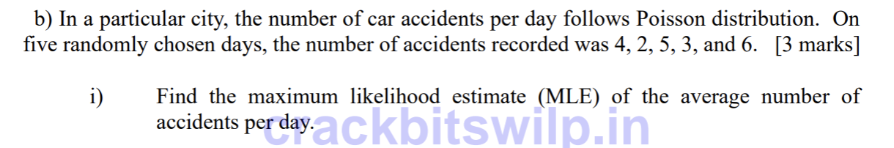
2025-2026 (13th Sept 2025) EndSem (Makeup) (AI&ML)
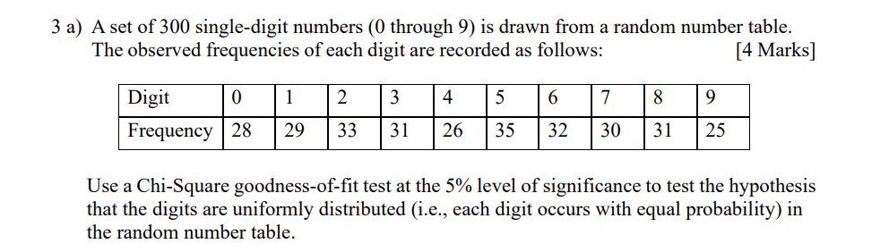

2023-2024 (April 2024) EndSem (Makeup) (AI&ML)
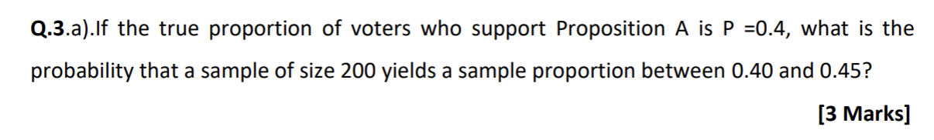
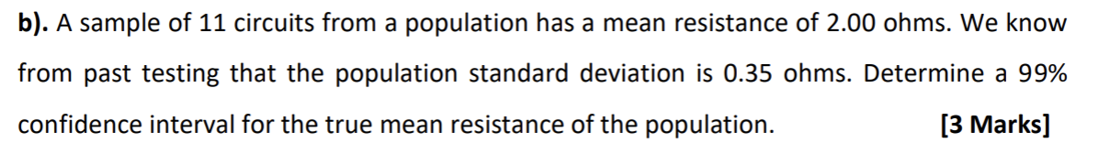
2025-2026 (18th Jan 2025) MidSem (Regular) (AI&ML)

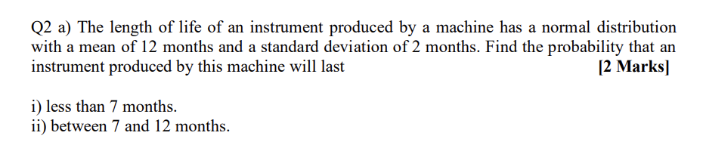

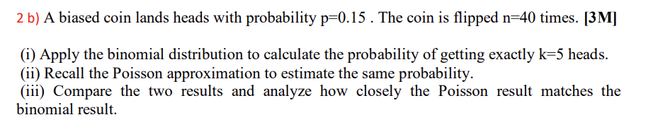

2024-2025 (28th Jun 2025) MidSem (Makeup) (AI&ML)
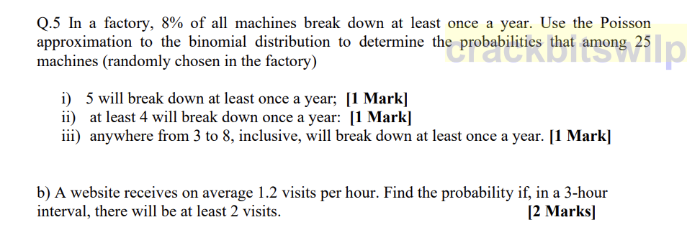

Webinars

Answers

ISM - EC2 - MidSem

Module 1: Basic Probability & Statistics

CS 1 - Measures of Central Tendency & Measures of Variability, Data – Symmetric & Asymmetric, outlier detection, 5 point summary, Introduction to probability

Question Papers

2022-2023 (28th Jan 2023) MidSem (Makeup) (DSE)

Important Observations from the Summary:
1. Presence of Outliers
- Several features have a very large gap between minimum and maximum values, e.g.:
  - compression_ratio: ranges from 7.0 -> 23.0
  - horsepower: 48 -> 288
  - engine_size: 61 -> 326
  - curb_weight: 1488 -> 4066
Such wide ranges compared to their means/std indicate possible outliers, which must be detected and handled during preprocessing.
2. Features Are on Different Scales (Normalization/Standardization Required)
The summary shows large variation in magnitude:
- curb_weight = 2555
- engine_size = 127
- bore = 3.3
- city_mpg = 25
- symboling = 0.83
Since the scales differ drastically, algorithms like KNN, SVM, logistic regression, and neural networks will require normalization or standardization.
3. No Missing Values
Every column shows:
- count = 205
This means the dataset has no missing values for these attributes, so imputation is not required, and the dataset is clean in this regard.
4. Skewness in Various Attributes
Some attributes have a noticeable difference between mean (average) and 50% percentile (median):
- horsepower: mean = 104.16, median = 95 -> right-skewed
- engine_size: mean = 126.9, median = 120 -> right-skewed
- curb_weight: mean = 2555, median = 2414 -> right-skewed
Such skewness indicates that:
- Data transformation (log, Box-Cox) to normalize distribution might improve model performance.
- Outlier or high-value observations are pulling the mean upward.

2022-2023 (8th Jan 2023) MidSem (Regular) (DSE)
2022-2023 (16th July 2023) MidSem (Regular) (AI&ML)

2023-2024 (03rd Feb 2024) MidSem (Makeup) (AI&ML)

2025-2026 (18th Jan 2025) MidSem (Regular) (AI&ML)

2024-2025 (28th Jun 2025) MidSem (Makeup) (AI&ML)

Webinars

CS 2 - Axioms of Probability, Mutually exclusive and independent events, Problem solving to understand basic probability concepts

Question Papers

2022-2023 (28th Jan 2023) MidSem (Makeup) (DSE)
Q1.
Justification (The statement is FALSE)
1. Mutually Exclusive Definition
- Two events A and B are mutually exclusive if:
P(A∩B)=0
2. Independent Events Definition
- Two events A and B are independent if:
P(A∩B)=P(A)⋅P(B)
3. Why Mutually Exclusive Cannot Be Independent
If events are mutually exclusive:
P(A∩B)=0
For them to be independent, we must also have:
0=P(A)⋅P(B)
This is possible only when at least one of the events has probability 0.
- If P(A)>0 and P(B)>0, then
P(A)⋅P(B)>0 but P(A∩B)=0 => Cannot be independent.
Thus, mutually exclusive events (with non-zero probability) are always dependent.
4. Independence Does NOT Mean Mutually Exclusive
If events are independent:
P(A∩B)=P(A)⋅P(B)
This value is greater than zero for non-zero probabilities, meaning the events can occur together -> So they cannot be mutually exclusive.
Conclusion
- Mutually exclusive events (with non-zero probability) are not independent.
- Independent events are not mutually exclusive.
- Therefore, the statement is invalid.

2023-2024 (21st Jan 2024) MidSem (Regular) (AI&ML)

2023-2024 (03rd Feb 2024) MidSem (Makeup) (AI&ML)

Webinars

Module 2: Conditional Probability & Bayes theorem

CS 3 - Introduction to conditional probability, independent events, Total probability

Question Papers

2022-2023 (28th Jan 2023) MidSem (Makeup) (DSE)
P(A)=1/2, P(B)=1/3, P(A/B)=1/6

P(A∩B) = P(A/B)⋅P(B) = 1/6×1/3 = 1/18
- P(B/A)
P(B/A) = P(A∩B)/P(A) = (1/18) / (1/2) = 1/9
- P(B/A′)
P(B/A′) = P(B∩A′)⋅P(A′) = P(B)-P(A∩B) / 1−P(A) = (1/3 - 1/18) / (1 - 1/2) = 5/9
- P(A⋃B/A)
Since A⊆A⋃B, given A the union certainly occurs:
P(A⋃B/A) = 1​
Also by formula, P(A⋃B/A) = P((A⋃B)∩A)/P(A) = P(A)/P(A) = 1
- P(B/A)
(This Question is the same as part (i).)
- P(A∩B′)
P(A∩B′) = P(A)-P(A∩B) = 1/2 - 1/18 = 4/9
- P(A′∩B′)
P(A′∩B′) = 1-P(A⋃B) = 1-(P(A)+P(B)-P(A∩B))=1-(1/2​+1/3​-1/18​)=2/9​.
- P(A′∩B)
P(A′∩B) = P(B)-P(A∩B) = 5/18
Given: Causes of road accidents
P(A) = Rash driving by self (A) = 15%
P(B) = Bad roads (B) = 25%
P(C) = Road indiscipline by others (C) = 20%
P(D) = Other reasons (D) = 40%
Death rates after these accidents:
P(S/A) -> 1%
P(S/B) → 2%
P(S/C) → 3%
P(S/D) → 4%

By Law of Total Probability,
P(S) = P(A)P(S/A)+P(B)P(S/B)+P(C)P(S/C)+P(D)P(S/D)
P(S) = (0.15×0.01) + (0.25×0.02) + (0.20×0.03) + (0.40×0.04)
P(S) = 0.0285 = 2.85%

2022-2023 (8th Jan 2023) MidSem (Regular) (DSE)

2022-2023 (16th July 2023) MidSem (Regular) (AI&ML)

2022-2023 (02nd April 2023) EndSem (Regular) (DSE)

2022-2023 (15th April 2023) EndSem (Makeup) (DSE)
Q4.

2023-2024 (21st Jan 2024) MidSem (Regular) (AI&ML)

2023-2024 (03rd Feb 2024) MidSem (Makeup) (AI&ML)

2023-2024 (April 2024) EndSem (Makeup) (AI&ML)

Webinars

CS 4 - Bayes theorem(with proof), Introduction to Naive Bayes concept.

Question Papers

2022-2023 (8th Jan 2023) MidSem (Regular) (DSE)
Q2.

2022-2023 (16th July 2023) MidSem (Regular) (AI&ML)

2023-2024 (21st Jan 2024) MidSem (Regular) (AI&ML)

2023-2024 (03rd Feb 2024) MidSem (Makeup) (AI&ML)

2025-2026 (18th Jan 2025) MidSem (Regular) (AI&ML)
2025-2026 (18th Jan 2025) MidSem (Regular) (AI&ML)

2024-2025 (28th Jun 2025) MidSem (Makeup) (AI&ML)

2024-2025 (28th Jun 2025) MidSem (Makeup) (AI&ML)

Webinars

Module 3: Probability Distributions

CS 5 - Random variables - Discrete & continuous, Expectation of a random variable, mean and variance of a random variable - Single random, random variable & Joint distributions
Question Papers
2022-2023 (28th Jan 2023) MidSem (Makeup) (DSE)

2022-2023 (8th Jan 2023) MidSem (Regular) (DSE)

2022-2023 (16th July 2023) MidSem (Regular) (AI&ML)

2023-2024 (21st Jan 2024) MidSem (Regular) (AI&ML)

2023-2024 (03rd Feb 2024) MidSem (Makeup) (AI&ML)

2023-2024 (Apr 2024) EndSem (Regular) (AI&ML)
2025-2026 (18th Jan 2025) MidSem (Regular) (AI&ML)

2025-2026 (18th Jan 2025) MidSem (Regular) (AI&ML)

2024-2025 (28th Jun 2025) MidSem (Makeup) (AI&ML)

2024-2025 (28th Jun 2025) MidSem (Makeup) (AI&ML)

Webinars

CS 6 - Bernoulli, Binomial, Poisson and Normal distributions. Introduction to t - distribution , F - Distribution and Chi Square distributions

Question Papers

2022-2023 (28th Jan 2023) MidSem (Makeup) (DSE)

2022-2023 (8th Jan 2023) MidSem (Regular) (DSE)
Q1.

2022-2023 (16th July 2023) MidSem (Regular) (AI&ML)

2022-2023 (02nd April 2023) EndSem (Regular) (DSE)
Q3.
2022-2023 (15th April 2023) EndSem (Makeup) (DSE)

2023-2024 (21st Jan 2024) MidSem (Regular) (AI&ML)

2023-2024 (03rd Feb 2024) MidSem (Makeup) (AI&ML)

2025-2026 EndSem (Regular) (AI&ML)
2025-2026 (13th Sept 2025) EndSem (Makeup) (AI&ML)

2023-2024 (April 2024) EndSem (Makeup) (AI&ML)
2025-2026 (18th Jan 2025) MidSem (Regular) (AI&ML)

2024-2025 (28th Jun 2025) MidSem (Makeup) (AI&ML)

Webinars

